Bahria University,

Karachi Campus



LAB EXPERIMENT NO.

**11**

LIST OF TASKS

|  |  |
| --- | --- |
| TASK NO | OBJECTIVE |
| **1** | **Consume all web services:** |
|  |  |

**Task 1: Consume all web services:**

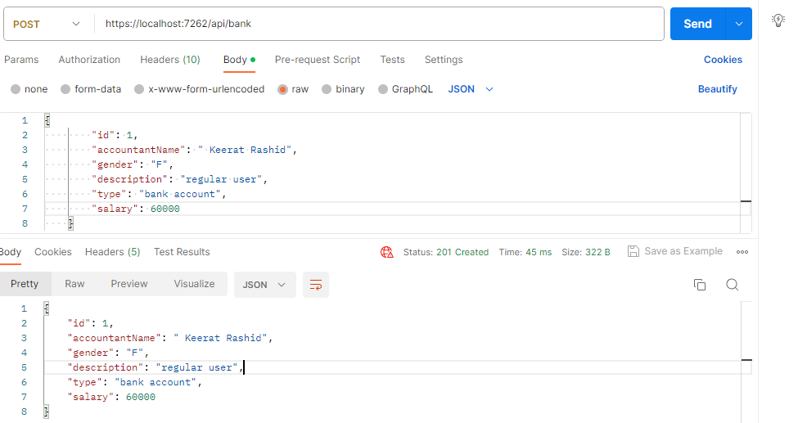

Hamza

Muaz

Kashif

Hamza

**Task 2: Consuming Product micro services.**

